

**artworks sharing platform**

**Software Design Document**

– HCM, March 2024 –

**Table of Contents**

I. Overview 3

1. Code Packages 3

2. Database Schema 3

II. Code Designs 4

1. <Feature/Function Name1> 4

a. Class Diagram 4

b. Class Specifications 4

c. Sequence Diagram(s) 4

d. Database queries 5

2. <Feature/Function Name2> 5

III. Database Tables 5

1. <Table name 1> 5

2. <Table name 2…> 5

# I. Overview

## 1. Code Packages/Namespaces

*[Provide the package diagram for each sub-system. The content of this section including the overall package diagram, the explanation, package and class naming conventions in each package. Please see the sample and description table format below – following Java project naming convention]*

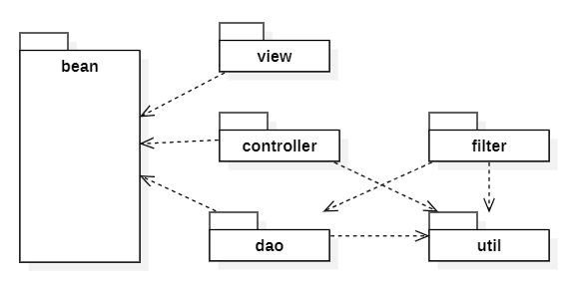

***Package descriptions & package class naming conventions***

|  |  |  |
| --- | --- | --- |
| **No** | **Package** | **Description** |
| *01* | *<Package name>* | *<Description of the package>*  *<Class naming convention>* |
| *02* |  |  |

## 2. Database Schema



***Table descriptions & package class naming conventions are as below***

|  |  |  |
| --- | --- | --- |
| **No** | **Table** | **Description** |
| *01* | *<Table name>* | *<Description of the table>*  *- Primary keys: <<list of primary key fields>>*  *- Foreign keys: <<list of foreign key fields>>* |
| *02* |  |  |

# II. Code Designs

## 1. <Feature/Function Name1>

*[Provide the detailed design for the function <Feature/Function Name1>. It include Class Diagram, Class Specifications, and Sequence Diagram(s)]*

### a. Class Diagram

*[This part presents the class diagram for the relevant feature]*

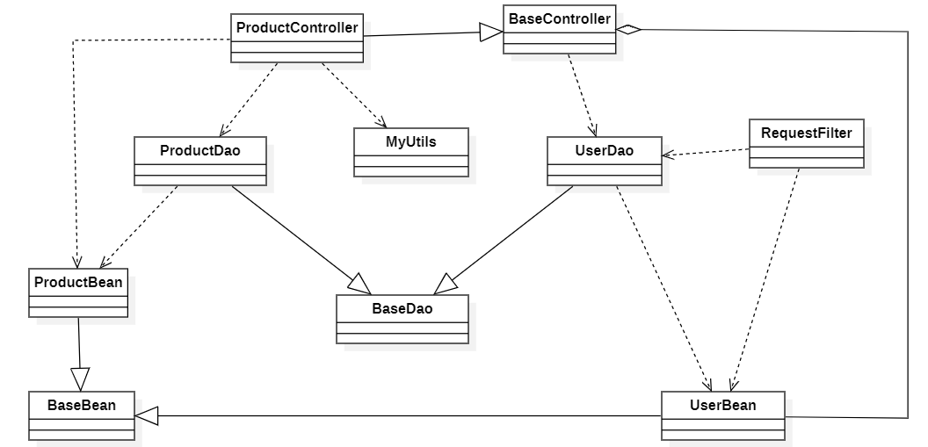

### b. Class Specifications

*[Provide the description for each class and the methods in each class, following the table format as below]*

#### XYZ Class

*[Provide the detailed description for the class methods]*

|  |  |  |
| --- | --- | --- |
| **No** | **Method** | **Description** |
| *01* | *<method name>* | *<Description of the method, including the inputs, outputs & internal method processing>* |
|  |  |  |

#### ABC Class

***Class Methods***

*[Provide the detailed description for the class methods]*

|  |  |  |
| --- | --- | --- |
| **No** | **Method** | **Description** |
| *01* | *<method name>* | *<Description of the method, including the inputs, outputs & internal method processing>* |
|  |  |  |

### c. Sequence Diagram(s)

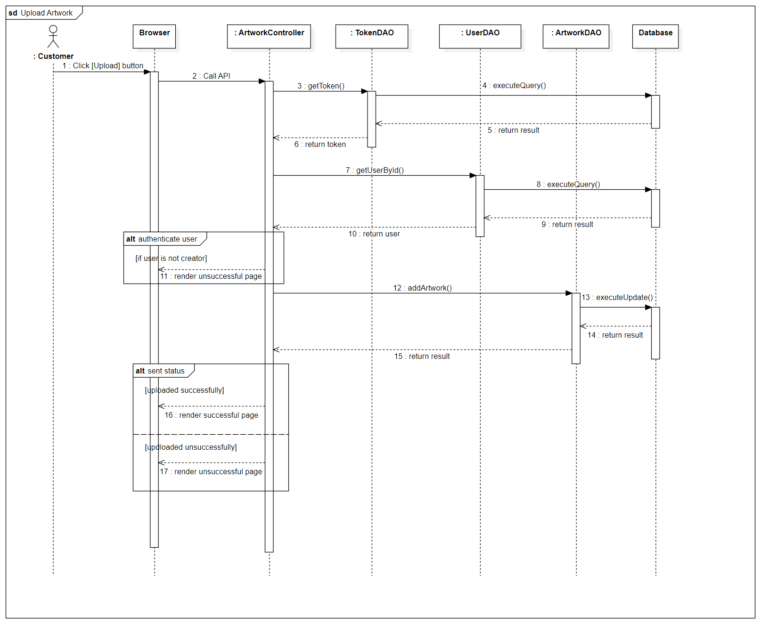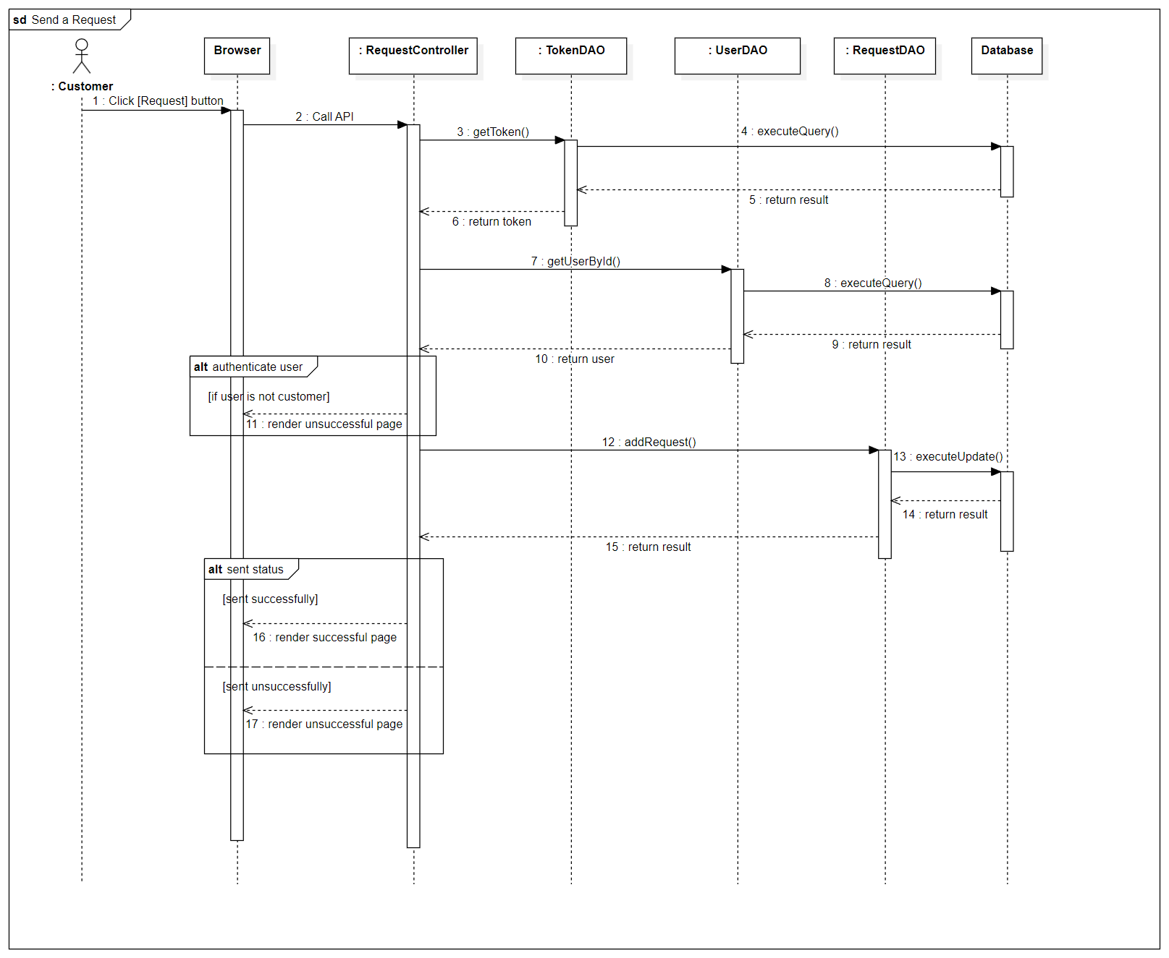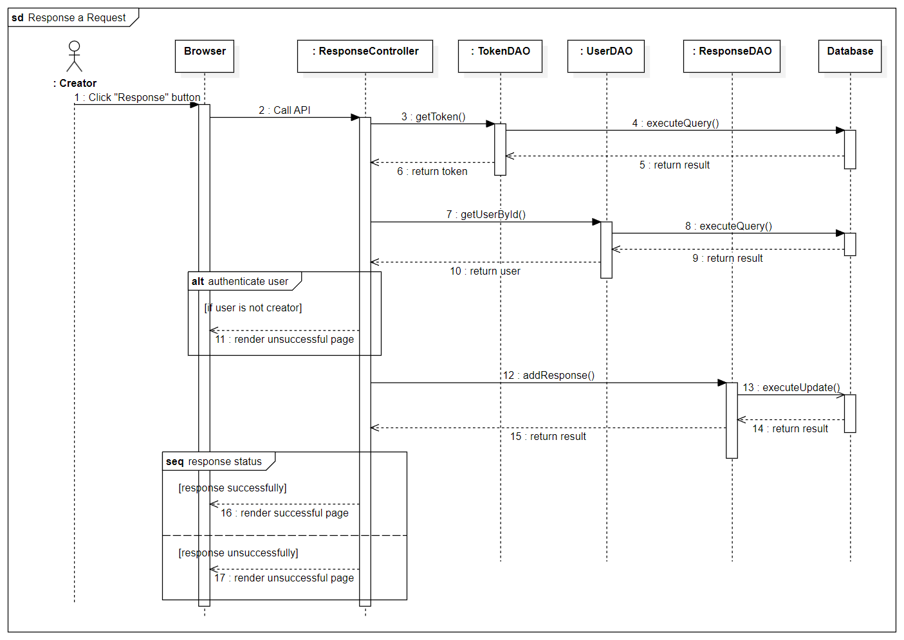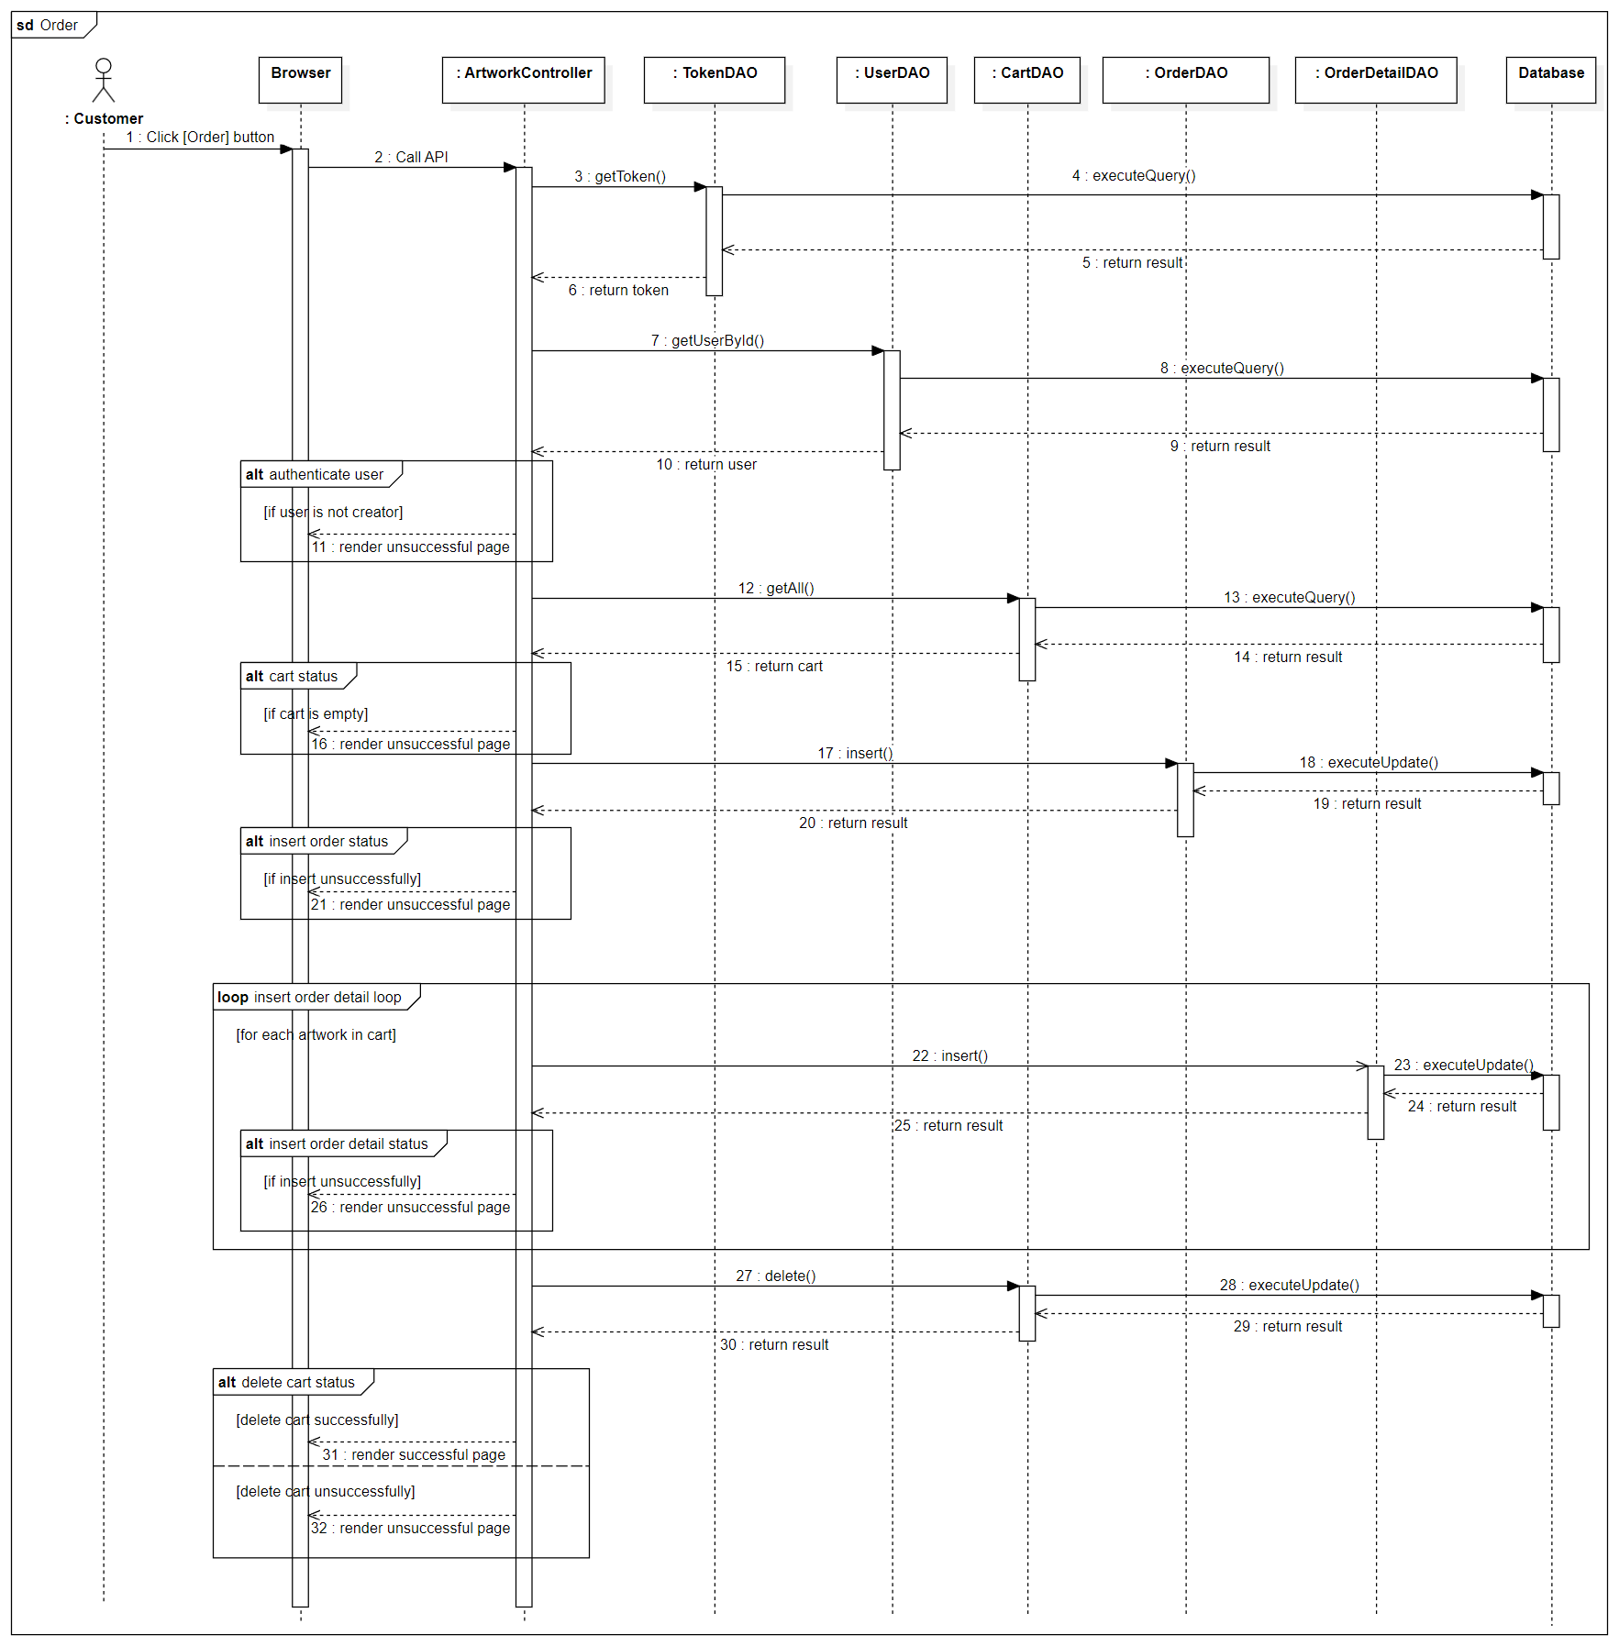

### d. Database queries

*[Provide the detailed SQL (select, insert, update...) which are used in implementing the function/screen]*

## 2. <Feature/Function Name2>

…

# III. Database Tables

## 1. <Artwork_reactions>

|  |  |  |  |  |  |  |  |
| --- | --- | --- | --- | --- | --- | --- | --- |
| **#** | **Field name** | **Type** | **Size** | **Unique** | **Not Null** | **PK/FK** | **Notes** |
| 1 | artwork_id | varchar | 20 |  | YES | PK, FK |  |
| 2 | user_id | varchar | 20 |  | YES | FK |  |

## 2. <Artworks>

|  |  |  |  |  |  |  |  |
| --- | --- | --- | --- | --- | --- | --- | --- |
| **#** | **Field name** | **Type** | **Size** | **Unique** | **Not Null** | **PK/FK** | **Notes** |
| 1 | artwork_id | varchar | 20 |  | YES | PK |  |
| 2 | owner_id | varchar | 20 |  | YES | FK |  |
| 3 | cate_id | Varchar | 20 |  | Yes | FK |  |
| 4 | Name | nvarchar | Max |  | YES |  |  |
| 5 | Description | nvarchar | Max |  | NO |  |  |
| 6 | Artwork_image | Varchar | 20 |  | YES | FK |  |
| 7 | Price | Float |  |  | YES |  |  |
| 8 | Released_date | Datetime |  |  | YES |  | Auto generate |
| 9 | Status | Int |  |  | YES |  |  |

## 3. <Users>

|  |  |  |  |  |  |  |  |
| --- | --- | --- | --- | --- | --- | --- | --- |
| **#** | **Field name** | **Type** | **Size** | **Unique** | **Not Null** | **PK/FK** | **Notes** |
| 1 | user_id | varchar | 20 |  | YES | PK |  |
| 2 | role_id | varchar | 20 |  | YES | FK |  |
| 3 | First_name | Nvarchar | 50 |  | YES |  |  |
| 4 | Last_name | nvarchar | 50 |  | YES |  |  |
| 5 | Phone | Varchar | 15 |  | YES |  |  |
| 6 | Email | Varchar | Max |  | YES |  |  |
| 7 | Address | Nvarchar | Max |  | YES |  |  |
| 8 | Join_date | Date |  |  | YES |  | Auto generate |
| 9 | Bio | Nvarchar | Max |  | YES |  |  |
| 10 | Status | Int |  |  | YES |  |  |
| 11 | Password | Varchar | Max |  | YES |  |  |
| 12 | Avatar | Varchar | Max |  | YES |  |  |